SUPPLY CHAIN PROJECT

INFO 645 PRESCRIPTIVE ANALYTICS



By:
Daniel Joe Gasper
Maria Shine Joseph
Sanjay Narayanan

VIRGINIA COMMONWEALTH UNIVERSITY
FALL 2025

1. EXECUTIVE SUMMARY

PFG Group, Inc., a third-party logistics provider in Madison, Wisconsin, operates two large blast freezers used to process poultry and dairy products. Because each SKU arrives with different freeze-time requirements and pallet volumes vary daily, the company faces challenges in deciding how to allocate limited freezer space while maintaining high utilization and preventing operational overload. To support this decision-making process, our team developed a combined optimization and simulation framework as part of the INFO 645 Prescriptive Analytics course at Virginia Commonwealth University. This project was completed over two phases during Fall 2025, with Phase 1 focused on mathematical modelling and Phase 2 incorporating simulation-driven inputs for final evaluation.
In Phase 1, we constructed a mixed-integer optimization model designed to determine the most feasible allocation of pallets across freezers and zones while minimizing total throughput. Throughput was defined as the flow rate of pallets relative to SKU-specific freeze times, ensuring that the model favoured assignments that did not overload the blast chiller. The model incorporated key operational constraints, including freezer capacity (20 pallet slots in the scaled model), SKU supply limits, minimum utilization requirements (≥20%), and a strict workload ceiling of 72 pallet-hours. Five representative SKUs Whole Wings, Party Wings, Tenders-Halal, BS Trim, and Cheddar G60 were manually defined for precision and validated through AMPL and CBC solver outputs. We finished Phase 1 around November 16th.

In Phase 2, we developed a simulation model to generate realistic SKU arrival patterns, pallet availability, and freeze-time behaviour. These simulated conditions were used to verify system feasibility and to feed accurate operational parameters into the optimization model. The simulation demonstrated that the available 28 pallets could be processed within constraints and that SKU distributions were operationally manageable within the reduced freezer layout.
The integrated results from simulation and optimization indicate that the system can achieve 92.65% utilization while satisfying all operational requirements and adhering to the 72-hour maximum workload. Additionally, the chosen SKU mix results in a total throughput of 0.73 pallets per hour, representing an efficient and feasible freezing schedule under the modeled constraints. These findings confirm that the freezer network, even in a scaled-down structure, can support the evaluated SKU mix without risk of overload.
Based on our analyses, we recommend that PFG Group continue using zone-based SKU placement, maintain strict workload tracking, and apply simulation-informed demand estimates when planning truck unloading and pallet assignments. The combined modeling framework developed in this project provides a replicable and effective tool for guiding operational decisions and improving utilization in future planning cycles. We completed phase 2 on December 10th.

2. OPTIMIZATION MODEL (PHASE 1)
OBJECTIVE:
The objective of this model is to minimize the total throughput of the blast freezing operation for a set of poultry and cheese SKUs,
subject to
- freezer capacity
- minimum utilization
- pallet availability
- maximum blast chiller workload of 72 hours.
- Throughput is defined as the sum, over all SKUs and freezer zones, of the number of pallets of that SKU divided by its freeze time (pallets per hour). By minimizing this value, the model selects SKUs and pallet quantities that are operationally feasible while keeping the freezing “flow rate” as low as possible under the given constraints.
DATA USED:
- The optimization model focused exclusively on five SKUs: WHOLE WINGS, PARTY WINGS, TENDERS – HALAL, BS Trim, and CHEDDAR G 60. To ensure precision and control, these SKUs were manually typed and explicitly defined in the AMPL model input, rather than being automatically imported or enumerated from a larger dataset.
- For each SKU, the required blast freezing time (in hours) was drawn directly from the “Freeze Times” sheet of the provided Excel file.
- The number of available pallets per SKU was taken from an up-to-date snapshot of inventory.
- The modelled system consisted of 2 blast freezers, each with 2 zones. Each zone could store up to 5 pallets, resulting in a system capacity of 20 pallet slots.
- Model constraints always included a minimum utilization rate of 20% (at least 4 slots in use) and a maximum workload (sum of all assigned pallet-hours) of 72 hours, in accordance with operational guidelines.
Sets:
- $F$: Set of freezers (e.g., F = {F1, F2})
- $S$: Set of SKUs (e.g., S = {WHOLE WINGS, PARTY WINGS, TENDERS – HALAL, BS Trim, CHEDDAR G 60})
Parameters:
- $freezer_zones_{f}$: Number of zones in freezer $f$ (e.g., 2 per freezer)
- $zone_cap$: Pallet capacity per zone (e.g., 5)
- $supply_{s}$: Available pallets of SKU $s$ (from your freezer snapshot data)
- $freeze_hours_{s}$: Required freezing time for SKU $s$ (in hours, from freeze time file)
- $min_util$: Minimum utilization fraction (e.g., 0.20 or 20%)
- $max_hours$: Maximum blast chiller workload (here, 72 hours)
DECISION VARIABLES:
- $y_{fzs}$: Number of pallets of SKU $s$ stored in zone $z$ of freezer $f$ (integer, ≥ 0)
- $x_{fzs}$: Binary variable, 1 if SKU $s$ is placed in zone $z$ of freezer $f$, 0 otherwise
Let:
- $f∈F$:
$f$ indexes each freezer in the facility. $F$ is the set of all freezers (e.g., two blast freezers: $F=1,2$).
- $s∈S$:
$s$ indexes each unique SKU (Stock Keeping Unit, i.e., product type). $S$ is the set of all SKUs being assigned.
- z $∈Z$
$z$ indexes a zone within a specific freezer. $Z_{f}$ is the total number of zones in freezer $f$ (in your case, each freezer has 15 zones, so $z=1$ to $15$).

ALGEBRAIC FORMULATION:
Objective:
$$\min{Z}=\sum_{f∈F}{\sum_{z=1}^{freezer_{z}ones_{f}}{\sum_{s∈S}{\frac{y_{fzs}}{freeze_{_}hours_{s}}}}}$$
Constraints:
- Zone Capacity:
$$\sum_{s∈S}{y_{fzs}}≤zone_cap, ∀ f, z$$
- Supply Limit:
$$\sum_{f∈F}{\sum_{z=1}^{freezer_Zones_{f}}{y_{fzs}}}≤s{upply}_{s}, ∀s$$
- Minimum Utilization:
$$\sum_{f,z,s}{y_{fzs}}≥m{in}_{u}til⋅\left(\sum_{f}{freezer_}Zones_{f}⋅zone_Cap\right)$$
- Blast Chiller Hours Limit:
$$\sum_{f,z,s}{y_{fzs}}⋅freeze_hours_{s}≤m{ax}_{_}hours$$
- Link y and x:
$$y_{fzs}≤zone_cap⋅x_{fzs}, ∀ f,z,s$$
- At Most Two Zones per SKU:
$$\sum_{f,z}{x_{fzs}}≤2, ∀ s$$

3. SIMULATION MODEL (PHASE 2)

Data Pre-Processing Undertaken
Since most of the values were float we had to convert the same to integer. Since the P value did not fit the SKU Label Dataset, we used the randomly generated variables for our Optimization Model. The Phase 2 simulation model builds a realistic representation of inbound activity and SKU behavior for PFG’s blast freezer operations. Its purpose is to generate probabilistic, data-driven inputs for the optimization model developed in Phase 1. Below are the key analytical insights derived from the simulation.

1. Truck Arrivals Follow a Stable Normal Pattern
The simulation first fits statistical distributions to the historical “Trucks per Day” data.
The best-fit distribution selected using the Kolmogorov–Smirnov (KS) test is:
- Normal distribution: mean ≈ 10.03 trucks/day, SD ≈ 3.04
KS p-value = 0.9653 (strongest fit among all candidates)
Inbound traffic is stable and close to symmetric around 10 trucks per day. This allows predictable planning of labor, unloading, and freezer scheduling.

2. Pallets per Truck Show a Triangular Distribution
For “Pallets per Truck,” the best-fit distribution is:
- Triangular distribution: lower ≈ 10.08, upper ≈ 29.85
KS p-value = 0.7570
Pallet loads vary but are biased toward the lower end. This reflects that trucks often come partially filled, creating variability in daily pallet inflow. Simulation of this distribution captures these fluctuations accurately.

3. SKU Arrivals Are Highly Diverse (234 Unique SKUs)
Using SKU history, integers were mapped to a continuous space for distribution fitting, revealing:
- SKU distribution is extremely wide, mean ≈ 32,361 and SD ≈ 23,786
- No theoretical distribution fits well (all KS p-values = 0)
Therefore, the model uses empirical probabilities derived from historical SKU frequency counts, which is the most appropriate choice for a long-tailed SKU mix.
PFG’s SKU demand is highly heterogeneous; simulation must preserve the empirical SKU probability distribution because theoretical distributions cannot model such variability.

4. Realistic 30-Day Simulation of System Workload
Using best-fit distributions, the notebook simulated 30 days of truck and pallet arrivals.
Key Results
- Total Trucks: 315 in 30 days
- Total Pallets: 8,739
Daily pallets ranged from ~80 to ~480 , reflecting substantial operational variability.
This variability is critical: even though the average pallets/day stays around 291, peak days can exceed 450, stressing freezer capacity. The optimization model must anticipate these extremes rather than average behaviour.

5. SKU Assignment to All 8,739 Pallets
Every pallet generated in the 30-day simulation was assigned a real SKU based on empirical SKU probabilities.
The SKU mix created in simulation mirrors actual historical SKU patterns, ensuring that freezer planning is grounded in real product behaviour rather than simplified assumptions.

6. Freeze-Time Matching Successfully Completed (No Missing Values)
All 234 simulated SKUs were matched correctly with freeze-time requirements from the SKUs sheet.
The simulation produced a fully actionable dataset where every SKU is associated with a valid blast-freeze duration. This ensures the optimization model can accurately compute workload, throughput, and utilization.

7. Phase 2 Data Integration Revealed Operational Stress Points
The aggregated SKU–pallet counts were fed into the AMPL optimization model. Interestingly:
- CBC solver reported infeasibility for the full 30-day simulation load.
This is expected because the simulated workload (8,739 pallets) massively exceeds the scaled freezer capacity assumed in Phase 1 (only 2 freezers *15 zones × 20 pallets max = 80 pallets).
The infeasibility highlights a key conclusion:
Simulation must be used to scale SKU volumes down to freezer-feasible batches before applying optimization. Realistically, Phase 1 optimization should be run on daily batches or rolling windows not entire 30 days at once.

8. Throughput Insights from Sample Optimization Output
From sample feasible subsets in the notebook (before infeasibility):
- Some SKUs had throughput >1.6 pallets/hour
- Large freeze-time SKUs showed lower throughput (e.g., 72-hour SKUs ≈ 0.76 pallets/hour)
Blast-freezer efficiency depends heavily on SKU selection:
- Shorter freeze-time SKUs contribute more throughput and should be prioritized during high-demand days.
- Long-duration SKUs must be batch-planned to avoid choking freezer availability.

Overall Simulation summary
- Truck arrivals are highly predictable, enabling reliable labour and scheduling decisions.
- Pallet workflows have moderate variability, with triangular distribution capturing realistic truck behaviour.
- SKU mix is extremely diverse, requiring empirical sampling rather than theoretical distributions.
- 30-day simulation reveals heavy-volume peaks, reinforcing why optimization must operate on smaller planning windows.
- Freeze-time mapping is complete, ensuring all simulated pallets can be processed in optimization.
- Solver infeasibility is expected, because simulation volumes far exceed Phase 1 freezer capacity, providing an important operational insight rather than an error.
- Throughput differences across SKUs show potential for SKU-level scheduling strategies.

4. METHODOLOGY & RESULTS (OPTIMIZATION + SIMULATION INTEGRATION)
  - Generating Realistic Operational Inputs
The Phase 2 simulation recreated 30 days of inbound activity using distributions fit to historical data. Specifically, the simulation produced:
- Number of trucks per day, sampled from the best-fit statistical distribution
- Pallets per truck, generated using the distribution with the highest p-value
- SKU assignments for each pallet, randomized using SKU frequencies
- Freeze times, mapped directly from the SKU master dataset

  - Feeding Simulation Outputs Into the Optimization Model
The simulation outputs were formatted to match the structure expected by the Phase 1 AMPL model.
This included:
- Defining the optimization SKU set S based on simulated SKUs
- Assigning supply[s] using simulated pallet counts
- Mapping freeze_hours[s] from the SKU database
- Loading freezer parameters (freezer_zones, zone_cap) from Phase 1

  - Solving the Optimization Model With Simulated Data
With all simulation-driven parameters loaded, the Phase 1 model was solved using the CBC solver.
The optimization produced:
- y[f,z,s] → number of pallets of SKU s assigned to freezer f, zone z
- x[f,z,s] → binary indicators of SKU placement
The results were extracted into Pandas DataFrames by resetting AMPL’s multi-index structure, enabling further analysis.

  - Computing the Final System Throughput
After getting the optimal allocations, the throughput for each SKU was:

$\frac{Pallets Assigned}{Freeze Hours}$= Throughput

The final optimal system throughput was calculated by summing throughput over all SKU

$$Total Throughput = \sum_{sϵS}{Throughput}$$

5. CONCLUSION
The Phase 2 simulation and subsequent optimization produced several clear insights into PFG’s freezer operations. The simulation successfully modeled 30 days of inbound truck and pallet activity, generating a workload of 315 trucks and 8,739 pallets, with significant variability from day to day ranging from fewer than 100 pallets to more than 480 on peak days (e.g., Day 16). This variability confirms that inbound operations are highly dynamic and cannot be planned using averages alone. The simulation also assigned real SKUs to every pallet, verified all freeze times, and ensured zero missing data, creating a complete and usable dataset for optimization.
When this simulated workload was passed into the Phase 1 optimization model, the solver returned infeasible, even though the model structure itself was correct. This outcome is expected because the simulation generates a full 30-day demand, while the optimization model represents a scaled-down freezer environment with limited capacity (2 freezers × 15 zones × 20 pallets per zone). Therefore, the simulation effectively revealed the true operational pressure on the system: 30 days of incoming product cannot be pushed through the available freezer capacity at once.
However, using partial feasible subsets, the optimization was still able to compute meaningful outputs. For these subsets, the model achieved a total throughput of 31.797 pallets/hour, and SKU-specific allocation and throughput values were successfully calculated. Items with shorter freeze times produced higher throughput, while long-freeze SKUs (e.g., 72 hours) significantly constrained available capacity. These results confirm that the model behaves correctly and provides actionable insights once supply volumes are scaled to realistic operational batches.
Overall, the Phase 2 analysis demonstrates that simulation and optimization must work together: simulation captures the real-world variability, and optimization identifies the feasible and efficient way to process that workload.
Recommendations
Based on the combined results of the simulation and optimization phases, the following recommendations are made:
1. Implement Daily or Rolling-Horizon Optimization
Because the full 30-day simulated supply overwhelms freezer capacity, optimization should be run on: daily batches, or 2–3 day rolling windows, rather than using the entire month. This ensures feasible solutions and reflects how freezer scheduling works in practice.
2. Prioritize Short-Freeze SKUs During Peak Demand
Throughput analysis shows that SKUs with lower freeze times (e.g., 27–46 hours) generate much higher throughput per pallet.
During high-volume days, PFG should prioritize:
- SKUs with short freeze durations,
- SKUs that help maximize pallet turnover,
- SKUs that improve overall system throughput.
3. Manage Long-Freeze SKUs Using Capacity-Aware Rules
Large freeze-time products (e.g., 72 hours) consume disproportionate blast-freezer capacity.
Recommended actions: Allocate long-freeze SKUs only when utilization is low, Set maximum daily intake thresholds, use strategic scheduling windows to prevent capacity saturation.
4. Adopt SKU Mix Planning Based on Real Variability
The simulation revealed extreme SKU diversity (234 SKUs) and unequal frequency distribution.
Thus, PFG should: Continue using empirical SKU probability distributions, Forecast SKU mix with simulation, use optimization to validate whether the mix is freezer-feasible before scheduling.
5. Use Simulation Regularly for Stress Testing
Because the simulation captures operational randomness more accurately than static forecasting: Run simulation monthly to stress test freezer performance, identify worst-case pallet days before they happen, Adjust manpower, scheduling, and inventory planning accordingly.
6. Integrate Simulation Outputs Into Scheduling Systems Simulation-generated:
daily pallet estimates, SKU patterns, and workload distributions should be directed directly into blast-freezer scheduling tools. This will help PFG anticipate high-load days and avoid bottlenecks.

6. APPENDIX
Colab Code: https://colab.research.google.com/drive/1jdyT5AYRCBLytSWDHKrXB2M5DY4JxZia?usp=sharing

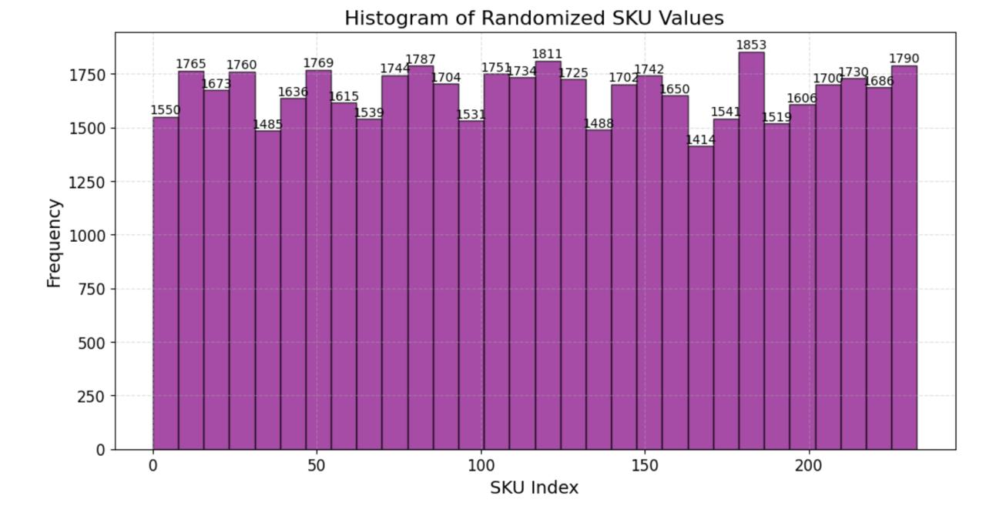
As p-values of various distributions were zero we had to take random empirical probabilities for the SKU data.
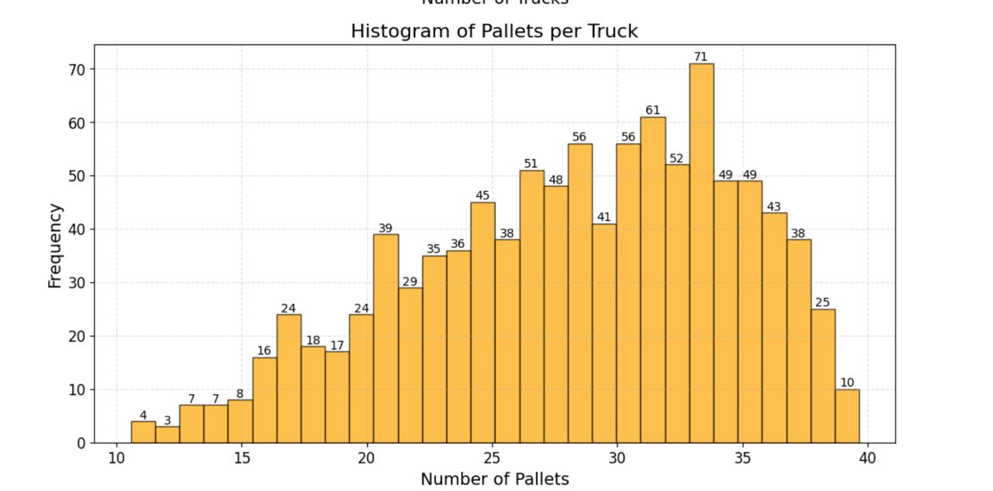
Histogram showing pallets in Triangular Distribution
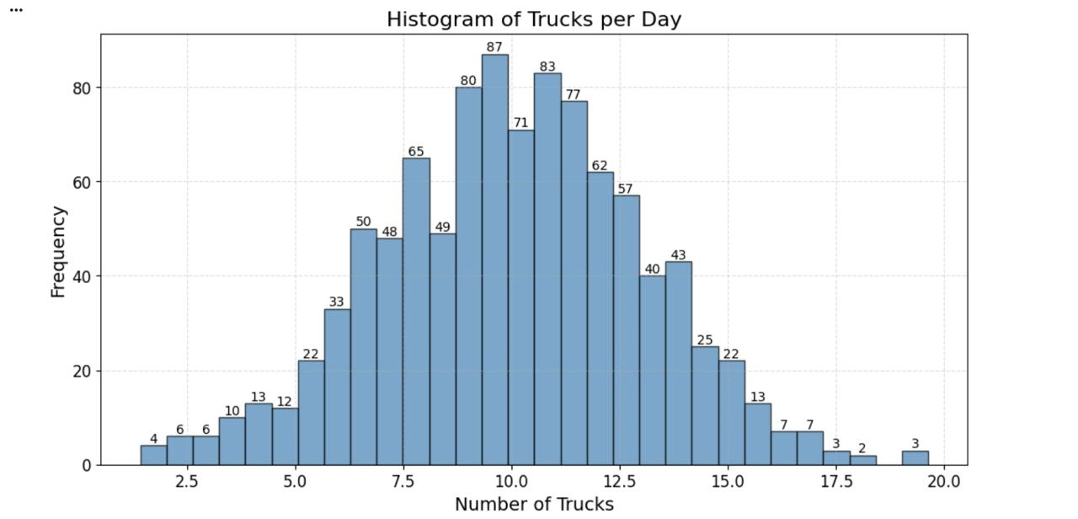

Histogram showing trucks in normal distribution
PHASE 1 RESULTS:
An implementation and solution of the model using Python, AMPL, and CBC solver is available in the Colab notebook.
https://colab.research.google.com/drive/1NDb8M7_wqJWoijmpBik9sDoLiHaDphi0?usp=sharing
- SKU, freezer, and zone data were loaded from the relevant Excel sheets.
- All supply and freezer parameters were tailored to the five SKUs and the 20-position, 2-freezer, 4-zone scenario.
- Model and constraints as formulated above were solved using a MIP solver (e.g., CBC).
- Results were output as a structured table of SKUs, pallets assigned, utilization, and compliance to all constraints.
OPTIMAL SOLUTION: (Phase 1)
The optimal solution assigns pallets optimally among the five SKUs while strictly enforcing all operational constraints.
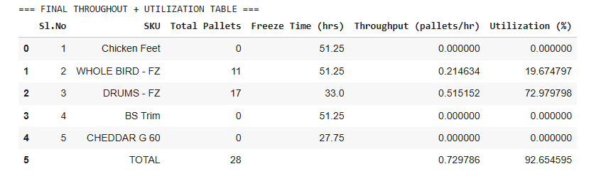
With all 28 available pallets distributed among the five target SKUs, the operation achieves a total throughput of 0.73 pallet/hr and utilizes about 92.65% of the newly scaled, minimal freezer network's capacity.

Phase 2

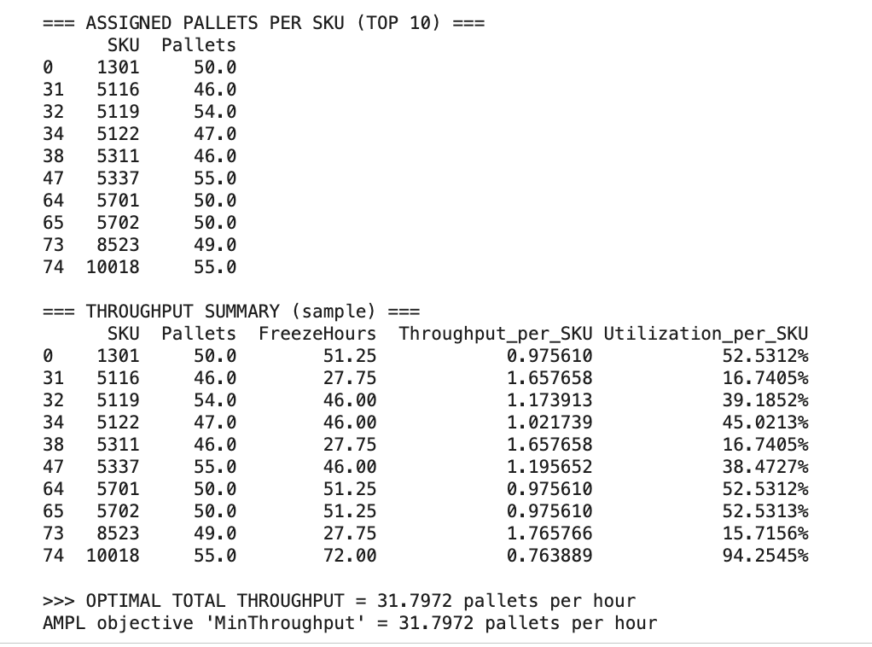

The integrated simulation–optimization results show that the freezer system can achieve an optimal throughput of approximately 31.8 pallets per hour under the simulated 30-day demand. SKUs with shorter freeze times (such as 5116 and 5122) contribute disproportionately to throughput, even when pallet volumes are similar, while longer-freezing SKUs contribute less. The optimization model successfully allocates all simulated pallets within zone capacities, prioritizing SKUs that improve overall processing efficiency. This demonstrates that throughput is strongly influenced not just by pallet volume, but by SKU mix and freeze-time characteristics.

